March 2015
Alsek Renewable Resource Council
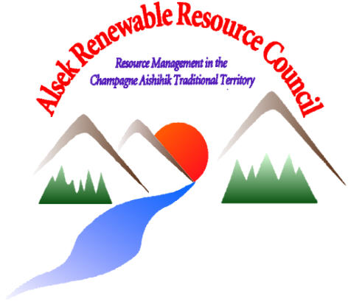

Upcoming Event
March 26 7pm- Mezzanine above Hockey Arena
Open Discussion- Kloo Lake burbot, Restocking Emerald Lake, and Health of Pine Lake. Tea/Coffee/Cookies

May 27
5th Annual BBQ at the Gun Range- All Welcome. 5pm

Emerald Lake-
Emerald Lake is a small pothole lake, just outside of Silver City.
Yukon Government has approached the Alsek RRC to ask if there was any interest to re-stock Emerald Lake to create a local fishing opportunity.
At this point this is all that would occur. There would be no additional infrastructure.
What are your thoughts? Let us know March 26th.

180 Alaska Hwy, Haines Jct, Yukon
www.alsekrrc.ca 867-634-2524
Kloo Lake- Burbot (Ling-cod)
On March 26th, the Alsek RRC would like to talk with you about Kloo Lake and the recent study that occurred in 2014.
The last population count in this lake estimated 270 adult burbot. This is very low. What’s going on? Lakes similar to Kloo would be expected to have a population of about 2700 adult burbot.
Currently there are about 45 setline license holders for Kloo Lake, they have all been contacted and informed about the very low population numbers. These permits expire March 31.
The Alsek RRC has been asked to support removing Kloo Lake from the approved list of set-lining lakes for burbot. As we learn more about our burbot populations in our region and others, we may need to start thinking about how to manage burbot for sustainable harvest opportunities across the Yukon.
What is your experience with fishing burbot in Kloo Lake? Have you seen changes occurring? We heard that there used to be lots of large burbot here, we have heard concerns about sediment filling in the north end of the lake, permafrost melt creating sink holes and stagnant black water as a result. Have you noticed any difference over the years that you have used this lake? Are there other lakes where you’ve noticed burbot changes? We would like to talk with you. Please join us March 26 at 7pm at the Mezzanine to hear about the survey performed on burbot in spring and fall 2014, and to discuss changes that have occurred in Kloo Lake and what may occur in the future.

More Important News

www.alsekrrc.ca
Check out our website, and look for us on Facebook.

ARRC Council Members-
Co-Chairs
Michelle Dawson-Beattie Jane Vincent
Members
Al Biggs Chuck Hume Larry Joe Bill Karman Doris Anderson-Alt Stephen Dyck- Alt Susan Smith- Staff

The Council meets the 2nd Monday of every month at their office. Our meetings are open to the public.

Up Coming Events
Community Dinner- April (Date to be decided…stay tuned!) The Alsek RRC, Champagne Aishihik First Nations and Yukon Government have been working together to create the first draft of the Fish and Wildlife Workplan for the Champagne Aishihik Traditional Territory. Though there is still work to be done on this plan, we want to invite you for a community get-together and offer some updates as to what we heard and discuss ideas around community monitoring.
BBQ- May 27th The Alsek RRC will be holding its annual BBQ in partnership with Conservation Officer Services, and the St. Elias Firearms Assc.
Everybody welcome to come and enjoy some good food, a chance to shoot some clay pigeons, and .22s (kids too!), while enjoying a beautiful evening.
What do you want from your RRC?
A new spring is dawning, and so is a new fiscal year! We want to be able to offer the community workshops or bring in speakers from other organizations. Last year we had a presentation from the Yukon Invasive Species Council that was really interesting. We have been brainstorming and would like to know if there is interest to host workshops for: sausage making or pressure canning wolf snaring/ trapping techniques bison hunting education spring bear awareness invasive species _______________________? (your idea here!) Call 634-2524, email admin@alsekrrc.ca, or tell your ARRC member what you’d like as a workshop.
For the past couple of years the ARRC has made snaring supplies available to trappers so that people can come here and make wolf snares. We intend to continue doing this. Call Susan or come see her to set up a time to make some.

